# **Validation Report Cost-Obj**

## *Summary Report*

*OBJECT*

IfcSlab.FLOOR

GlobalId: 3qgEayMZ55yxnk8LFa1i7K

Obj Name: Pavimento:PAV_STR_LT_30_CA5_LT25:139442

*COST ITEM*

IfcCostItem

Price List Code: OC.EEA.a04.E0200.L0011.0105.-

GlobalId: 1Q2Zm4gIDDmxJgzYoZxKEG

Cost Name: Brick floor thickness 29cm

*CHART*

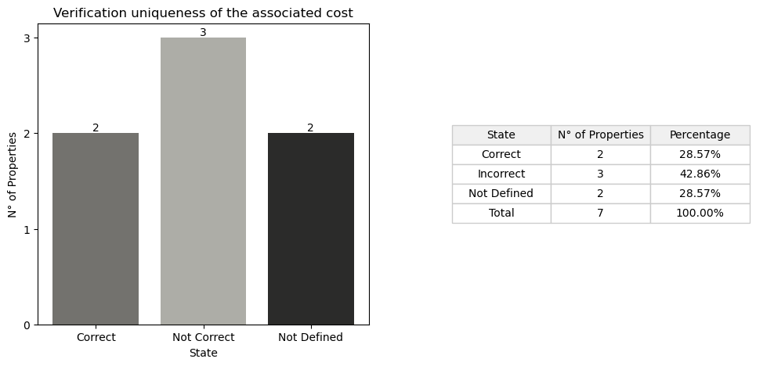

## *Detail Table*

|  |  |  |
| --- | --- | --- |
| **State** | **N° of Properties** | **Properties** |
| Correct | 2 | Entity TypeEnum |
| Incorrect | 3 | IsExternal LoadBearing Width |
| Not Defined in the obj | 2 | Compartimentation Status |
| Not Defined in the cost | 1 | PitchAngle |
| Not Defined in the cost and obj | 3 | ThermalTrasmittance AcousticRating FireRating |

## *Detail Report*

**🔸Number of Correct Properties: 2**

Entity: ✓   
 • #20=IfcSlab('1CV6D5GpTBygk1cJC32nu3',$,'Sample element of brick floor','Sample element of brick floor',$,$,$,$,.FLOOR.)   
 • #1100=IfcSlab('3qgEayMZ55yxnk8LFa1i7K',#21,'Pavimento:PAV_STR_LT_30_CA5_LT25:139442',$,'Pavimento:PAV_STR_LT_30_CA5_LT25',#1092,#1099,'139442',.FLOOR.)   
  
TypeEnum: ✓   
 • #20=IfcSlab('1CV6D5GpTBygk1cJC32nu3',$,'Sample element of brick floor','Sample element of brick floor',$,$,$,$,.FLOOR.)   
 • #1100=IfcSlab('3qgEayMZ55yxnk8LFa1i7K',#21,'Pavimento:PAV_STR_LT_30_CA5_LT25:139442',$,'Pavimento:PAV_STR_LT_30_CA5_LT25',#1092,#1099,'139442',.FLOOR.)

**🔸Number of Incorrect Properties: 3**

IsExternal: ✗   
 • #24=IfcPropertySingleValue('IsExternal','Indication whether the element is designed for use in the exterior (TRUE) or not (FALSE). If (TRUE) it is an external element and faces the outside of the building',IfcBoolean(.T.),$)   
 • #144=IfcPropertySingleValue('IsExternal',$,IfcBoolean(.F.),$)   
  
LoadBearing: ✗   
 • #25=IfcPropertySingleValue('LoadBearing','Whether this component is carrying (YES) or not carrying (NO)',IfcBoolean(.T.),$)   
 • #1146=IfcPropertySingleValue('LoadBearing',$,IfcBoolean(.F.),$)   
  
Width: ✗   
 • #38=IfcQuantityLength('Width','Thickness of the floor, the value is given only if the thickness is constant',#3,0.29,$)   
 • #1140=IfcQuantityLength('Width',$,$,0.29999999999999999,$)

**🔸Number of Not Defined Properties in Obj: 2**

Compartimentation: ✗   
 • property not found in OBJ  
  
Status: ✗   
 • property not found in OBJ

**🔸Number of Not Defined Properties in Cost Item: 1**

PitchAngle: ✗   
 • property not found in COST ITEM

**🔸Number of Not Defined Properties in Cost Item and Obj: 3**

ThermalTrasmittance: ✗   
 • property not found in OBJ and COST ITEM  
  
AcousticRating: ✗   
 • property not found in OBJ and COST ITEM  
  
FireRating: ✗   
 • property not found in OBJ and COST ITEM